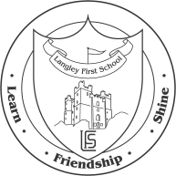

Carol Service

Dear Parent,

If you would like to attend your child’s Carol Service at St Andrew’s Church, Monkseaton on Wednesday 19th December please complete the box below and return to the school office by Friday 7th December. Tickets will be sent out by Friday 14th December at the latest.

Due to the size of the church, every child is eligible for two tickets only.

Yours sincerely,

Mr. T Jones
Headteacher

Year 3 and Year 4

Carol Service

We would like ____ ticket/s for the Carol Service on Wednesday 19th December at 2.00 p.m.

Child’s Name:________________________ Class:____

