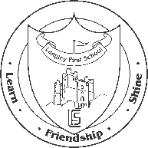
Please help us support Children in Need this year
As a school council we have decided that we would like to invite all the children in our school to come on Friday 16th November in non-uniform but wearing spots or stripes to mark Children in Need. We would like everyone who can to donate £1 for this.
To make this year a bit different we are also offering everyone the chance to enter our ‘Design a face’ competition. For 50p you can create a design on the sheet attached. On Friday morning we will then pick out designs at random alongside the names of staff. The children of those designs chosen will then get the chance to create them on the staff members face! So if you would like to have the chance to put face paint on your teacher’s face then get designing!

Thank you for your support and we hope you enjoy designing.

Langley First School - School Council
__________________________________________________________________________________
Design a Teacher’s Face
Please complete your design below and then return to school on or before Friday 16th November with your 50p contribution. Don’t forget to put your name below!
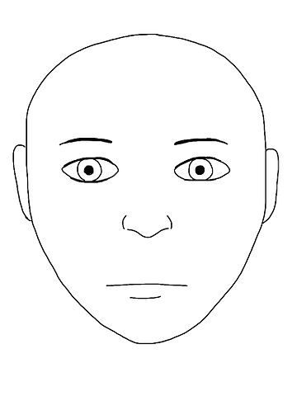
Name ____________________________________ Class ___________________________

