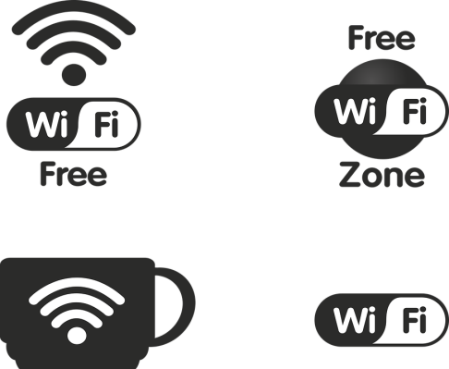****

**Thursday 27th December**

**Toddler Tales**

**14:00pm – 14:30pm**

**Whitley Bay Customer First Centre 0191 6438804**

**Friday 21st December**

**Breakfast with Santa**

**10:30am – 12:00pm**

**Enjoy some tasty treats with Santa in his grotto.**

**Booking Required!**

**Whitley Bay Customer First Centre**

**0191 6438804**

**Thursday 27th December**

**Well Baby Clinic**

**1:00pm – 2:00pm**

**Health related advice 0-5**

**Waves Leisure Centre**

**0191 6432600**

**Thursday 27th December**

**Marching Tots**

**10:30am – 12:00pm**

**Whitley Bay Customer First Centre 0191 6438804**





**Christmas Activities**

**Coast Locality Team**

**21st December – 4th January 2019**

**Whitley Bay Customer First Centre, York Road, Whitley Bay, NE26 1AB**

**For more information please call the venue**