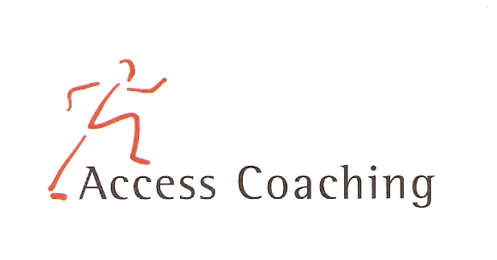

YEAR 3 & 4 AFTER SCHOOL FUTSAL CLUB

LANGLEY FIRST SCHOOL

COURSE DATES Monday 14th, 21st, 28th Jan & 4th, 11th Feb (3.20 – 4.20pm)
Course Content: Futsal is a small sided version of Football that is played worldwide on a smaller pitch and mainly played indoors. Futsal is played between two teams of five players each, one of whom is a goalkeeper. Futsal is also played with a smaller ball with less bounce than a regular football. The surface, ball and rules create an emphasis on improvisation, creativity and technique as well as ball control and passing in small spaces. The Sessions will concentrate on developing technique and having lots of fun.
Personal Requirements: Children are expected to provide their own kit. This should include School PE kit or shorts, t-shirt, trainers and a jumper (for possible outdoor sessions). Children are required to bring a still drink.

Applications: All applications should be made by completion of the attached form. Applications should be returned by Thursday 20th Dec 2018 to the school office. We will only contact you if your child does not get a place.

Course fee: £12.50 for 5 weeks

Access Coaching: For more information please contact James Carron (Director of Sport and Coaching) on 07508217681

YEAR 3 & 4 AFTER SCHOOL FUTSAL
Child’s name:

Address:
Postcode:

Tel: Email: Applicant D.O.B: Age:

Langley First School Class:___________

Please inform us of any Medical Information or Special Requirements:
____________________________________________________________________________
Emergency Contact number:______________________

I would like my child to participate in the 5 week after school Futsal coaching course and I enclose the course fee of £12.50 (cash or cheque made payable to Access Coaching).

I understand that Access Coaching cannot be held liable for any personal loss or injury that the participant may sustain whilst attending one of the coaching courses. Signed:..……………………………………………………………………… (Parent/Guardian)

