At Langley First School we teach our children from a very young age about how to keep safe using online technology through fun activities, web resources and animations. During e-safety week (4th - 8th February) we will be working on lots of exciting projects to help children to understand how to stay safe and enjoy using online technology.
Safer Internet Day and Digital Confidence at Langley

Years 1 and 2 – On Thursday 7th February
Classes 3, 4, 5 and 6 will take part in hour-long workshops which explore how to use technology safely and responsibly. The drama–based workshops use playful and fun storytelling to help the children realise that cyber space is perhaps not so different from the real world after all!
Years 3 and 4 – On Friday 8th February
The children in Year 3 will be participating in an exciting drama workshop that tackles a range of internet safety issues, such as gaming and what constitutes safe user habits. At the end of the day there will be a short performance for parents and Year 4 pupils highlighting what they have learnt.
Parents and carers of pupils in Year 3 are invited into school at 3.00pm to watch the performance.
Resources to help support safety at home:
https://www.thinkuknow.co.uk/5_7/ | Fun animation with clear messages about being safe online for children aged 5 to 7.
Online games and activities for children aged 8 to 10. | https://www.thinkuknow.co.uk/8_10/  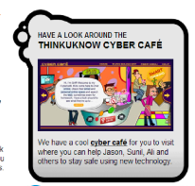
For LOTS more resources and up to date parent information regarding E-Safety please visit the webpage below or scan the QR code!

http://airhead.io/public/launchpads/-UYkZ2rDukSQo7NaabcPpQ
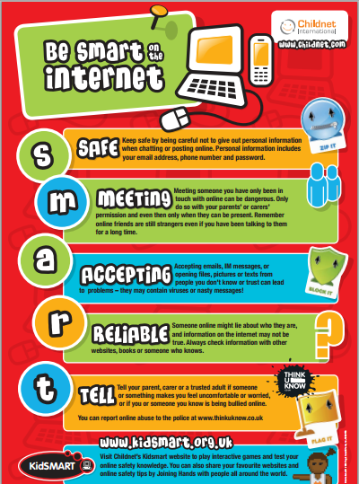
Top Tips for parents about helping your child keep safe online:
- Talk to your child about what they’re up to online. Be a part of their online life; involve the whole family and show an interest.
- Watch Thinkuknow films and cartoons with your child. The Thinkuknow site has films, games and advice for children from five all the way to 16.
- Encourage your child to go online and explore! There is a wealth of age-appropriate sites online for your children. Encourage them to use sites which are fun, educational and that will help them to develop online skills.
- Keep up-to-date with your child’s development online. Children grow up fast and they will be growing in confidence and learning new skills daily.
- Set boundaries in the online world just as you would in the real world. Think about what they might see, what they share, who they talk to and how long they spend online.
- Keep all equipment that connects to the internet in a family space.
- Know what connects to the internet and how. Nowadays even the TV connects to the internet. Make sure you’re aware of which devices that your child uses to connect to the internet, such as their phone or games console.
- Use parental controls on devices that link to the internet, such as the TV, laptops, computers, games consoles and mobile phones.

