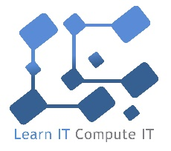

To all those interested in computers and coding
Do you like music? Would you like to be able to create your own music on a computer? Then come to the Learn IT Compute IT Computing Club.
At the Computing Club, we will be using Sonic Pi to write music through code to use different sounds and notes to create amazing soundscapes. Sonic Pi lets you learn to code creatively by composing or performing music in an incredible range of styles.
My experience with computing and coding includes over 14 years of teaching, developing resources for use by others, running STEM activities and other community coding activities. In addition to teaching I have had extensive experience working professionally in the IT sector and studied Electronic Engineering. I am also a Raspberry Pi Certified Educator.
The Computing Club is open to children in Year 4 and is restricted to 16 spaces, limited by the number of robots available. The participants will work individually and in pairs with the aim of developing collaborative skills to produce more complex creations. The club will run on Thursdays after school from 3.30 to 4.30 for 5 weeks commencing on Thursday 17th January and finishing on Thursday 14th February. The club costs £30 for the 5 sessions.
Please respond by completing and returning the attached reply slip by Tuesday 15th January.
Best wishes
Marty from Learn IT Compute IT

I would like my son/daughter to attend the Learn IT Compute IT Computing Club

Pupils name_________________________________________ Class_______________

I am including payment for £30 for the Computing Club

Signature of parent/guardian _____________________________________________________

