English
We will begin the new year with all things penguin, as we begin to learn about explorers and adventurers who have spanned the globe through exciting new texts in our literacy lessons.
We will continue to develop our spelling and grammar skills through new texts, such as ‘Lost and Found’, ‘Penguin’, ‘Beegu’ and ‘A River’.

Maths
Develop problem solving skills with addition, subtraction, multiplication and division.
Continue to develop reasoning skills with fractions.
Learn to tell the time to 5 minute intervals on an analogue clock.
Explore measures and positional language.

Science
Discover different animal habitats around the world and discover how some animals are well-suited to their habitats.
Create and study food chains.
Observe how a seed grows in to a plant.

R.E.
Christianity, The Bible and stories that Jesus told. Why we celebrate Easter.

Computing
Introduction to code writing and programming, writing algorithms and debugging simple programs using Scratch.
How to stay safe online.

History
Study the lives of famous people from history, particularly explorers like Robert Falcon Scott, Christopher Columbus and Amy Johnson.
Discover the story of The Titanic and the famous people involved.

P.S.H.C.E.
How to make and maintain friendships and resolve conflicts. Describe different feelings and emotions.

Art
Respond to paintings created by Seurat by creating our own pointillism pictures with a variety of techniques.
Begin to explain preferences to different styles and artists.

Design Technology
Investigate different techniques before designing, creating and evaluating our own moving picture.

P.E.
Dance inspired by our topic work, gymnastics and games.

Geography
Identify the world’s oceans, the equator, the North and South Poles and make predictions about the weather in other parts of the world.
Plot and describe the journey of The Titanic, Columbus and Scott of Antarctica.

Music
Use percussion instruments to compose and perform.
Begin to use tuned instruments to perform simple melodies.

French
To say our age, numbers up to 20 and the days of the week en français.
Learn a short story in French.

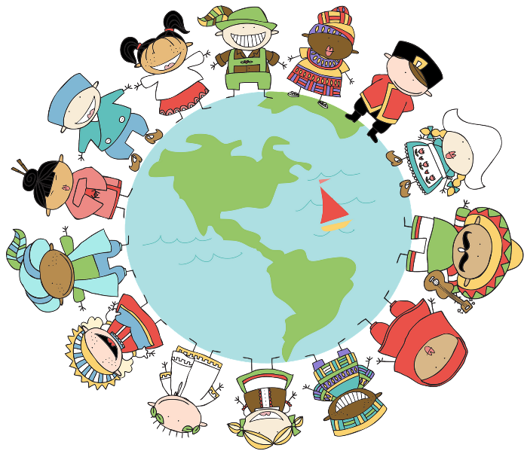

English
https://drive.google.com/open?id=1IxjWFpeCWRjNn_iZnzZ3adOjOMNY_JtW5j5-QFOPFhQ

https://drive.google.com/open?id=13WNo9PUl0MuaI6Mi8NvljTJYf0dygVM6mBqMoBD1Unk

https://drive.google.com/open?id=1s7CXJEMTYUnj9ZF6Cc92UO7WX5_8nzX5w0pno4oYHss

Maths
https://drive.google.com/open?id=1JOO3epABO2C4rPwkhz6_ngUNLUcs6Ow9JNo3qH5eS0M

Science
KPI: To ask relevant questions and begin to suggest independently how they could be answered.
KPI: To gather, record, classify and present data in a variety of ways to help in answering questions.
KPI: To report findings using simple scientific language, drawings, labelled diagrams, bar charts and tables.
KPI: To use results to draw simple conclusions and suggest improvements, new questions and predictions for setting up further tests.
TT: To observe and describe how seeds and bulbs grow into mature plants.
TT: To find out and describe how plants need water, light and suitable temperature to grow and stay healthy.
TT: To describe the importance for humans of exercise, eating the right amount of different types of food, and hygiene.

TT: To identify that most living things live in habitats to which they are suited and describe how different habitats provide for the basic needs of different kinds of animals and plants, and how they depend on each other. TT: To identify and name a variety of plants and animals in their habitats, including micro-habitats.

Computing
TT: To use technology purposefully to create, organise, store, manipulate and retrieve digital content. TT: To use technology purposefully to create digital content comparing the benefits of different programs.
TT: To use technology safely and keep personal information private.
To know how to stay safe on the internet.
TT: To use logical reasoning to predict the behaviour of simple programs.
To look at a set of instructions and predict what will happen.
TT: To create simple sets of instructions.
To understand the word algorithm and can create and edit a set of instructions.
TT: To create and debug simple programs.
To test and edit a robot to make instructions more effective.
TT: To debug programs by using logical reasoning to predict the actions instructed by code.
TT: To understand that programs execute by following precise and unambiguous instructions.
To understand how a website is organised.
To open, edit and save ideas and use a variety of different programmes.

R.E.

History
TT: To use a wide vocabulary of everyday historical terms.
TT: To speak about how he/she has found out about the past.
To answer questions by using specific source such as an informative book or website.
To know about a famous event that happens somewhere else in the world and why it has been happening for some time.
TT: To record what he/she has learned by drawing and writing.
To ask and answer questions such as What was it like for a…? What happened? How long ago?
TT: To discuss the lives of significant individuals in the past who have contributed to national and international achievements and use some to compare aspects of life in different periods.
To research the life of a famous person from the past using different resources to help them.
To make comment on why people did things, why events happened and what happened as a result.

P.S.H.C.E
I can talk about things I like and dislike. I know how to make real, informed choices that improve my physical and emotional health.
I recognise that choices can have good and not so good consequences.
I can recognise and celebrate my strengths and set simple but challenging goals.
I can talk about change and loss and the associated feelings (including moving home, losing toys, pets or friends)
I know how some diseases are spread and can be controlled by good personal hygiene and medication
I know some things I can do to help my own health and that of others (i.e. wash hands)
I can name the main parts of the body (including external genitalia) and talk about the similarities and differences between boys and girls
I know rules for and ways of keeping physically and emotionally safe (including safety online, the responsible use of ICT, the difference between secrets and surprises and understanding not to keep adults’ secrets; road safety, cycle safety and safety in the environment (including rail , water and fire safety))
I know that household products, including medicines, can be harmful if not used properly
I recognise that I share a responsibility for keeping myself and others safe.
I know when to say, ‘yes’, ‘no’, ‘I’ll ask’ and ‘I’ll tell’
I know what is meant by ‘privacy’; right to keep things ‘private’ and the importance of respecting others’ privacy.
I understand what is meant by ‘privacy’, that I have right to keep things ‘private’ and the importance of respecting others’ privacy

Art
KPI: To try out different activities and make sensible choices about what to do next.
To use a viewfinder to focus on a specific part of an artefact before drawing it.
To use different grades of pencil in drawings.
To use charcoal, pencil and pastels.
To mix paint to create all the secondary colours.
To make tints by adding white and tones by adding black.
To create a print using pressing, rolling, rubbing and stamping.
To use simple IT mark-making tools, e.g. Brush and pen tools.
KPI: To give reasons for his/her preferences when looking at art/craft or design work.
To say how other artists have used colour, pattern and shape.
To create a piece of work in response to another artists work.

Geography
TT: To understand geographical similarities and differences through studying the human and physical geography of a small area of the UK and of a small area in a contrasting non-European country.
To describe a place outside Europe using geographical words.
To explain how the jobs people do may be different in different parts of the world.
TT: To use simple compass directions (N,E,S,W) and locational and directional language e.g. near and far; left and right to describe location of features and routes on a map.
TT: To use aerial photographs and plan perspectives to recognise landmarks and basic human and physical features; devise a simple map; and use and construct basic symbols in a key.
To consider how people often ‘spoil’ the area or make it better.
TT: To name and locate the world’s seven continents and five oceans.
TT: To identify seasonal and daily weather patterns in the UK and the location of hot and cold areas of the world in relation to the Equator ad the North and South Poles.

Music
TT: To build an understanding of the pulse and internalise it when listening to a piece of music.
To sing/clap, pulse increasing or decreasing in tempo.
TT: To improvise a simple rhythm using different instruments including the voice.
To play simple rhythmic patterns on an instrument.
TT: To understand that timbre describes the character or quality of a sound.
TT: To understand that texture describes the layers within music.
TT: To understand that structure describes how different sections of music are ordered.
TT: To begin to describe a piece of music using a developing understanding of the interrelated musical dimensions
To listen out for particular things when listening to music.
TT: To use his/her voice expressively and creatively by singing songs and speaking chants and rhymes with growing confidence.
To sing and follow the melody (tune).
TT: To develop an understanding of melody, the words and their importance in the music being listened to.
To perform simple patterns and accompaniments keeping a steady pulse.
To use symbols to represent sounds.
TT: To play instruments using the correct techniques with respect.
To make connections between notations and musical sounds.

Languages

D.T.
KPI: To understand that all food has to be farmed, grown or caught
KPI: To design purposeful, functional, appealing products for himself/herself and other users based on design criteria.
To evaluate a product against design criteria.
KPI: To generate, develop, model and communicate his/her ideas through talking, drawing, templates, mock-ups and, where appropriate, information and communication technology.
KPI: To choose appropriate tools, equipment, techniques and materials from a wide range.
KPI: To safely measure, mark out, cut and shape materials and components using a range of tools.
To think of ideas and plan what to do next.
To measure materials to use in a model or structure.
KPI: To evaluate and assess existing products and those that he/she has made using a design criteria.
To write a set of simple design criteria.
To explain what went well with own work.
KPI: To investigate different techniques for stiffening a variety of materials and explore different methods of enabling structures to remain stable
To join things (materials/ components) together in different ways.
KPI: To explore and use mechanisms e.g. levers, sliders, wheels and axles, in his/her products.

