
World Book Day
This year, World Book Day will be on Thursday 7th March and as usual, we will be celebrating reading in a variety of ways across the day.
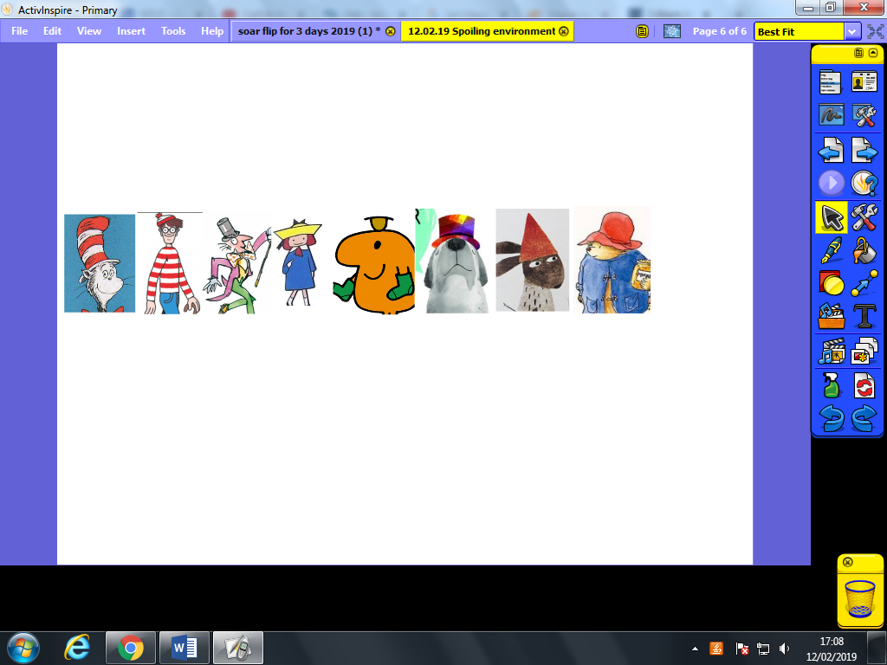
Hats, hats, hats
As a way to raise money for Book Aid International, we will encourage everyone to come to school dressed as a character from a book for a donation of £1. The theme this year is hats, including every character from Willy Wonka to Wally.
Book Swap
Each class will also be giving the children an opportunity to swap books that they’ve finished with from home. If your child has a book to swap with a classmate, please make sure they bring it with them.

Borrow Box
I’d also like to take this opportunity to let you know about the app Borrow Box. This app is part of the library service, and can be downloaded on any tablet or smartphone. With a library card and number, you will be able to have access to a huge variety of e-books and audio books for free. We consider this a great opportunity for our children and adults to explore even more books from home. You can log in with the number on your library card, with your password being the last 4 digits of that number initially.
There will be many more activities taking place on World Book Day across the school.
Thank you
Mr Massey

