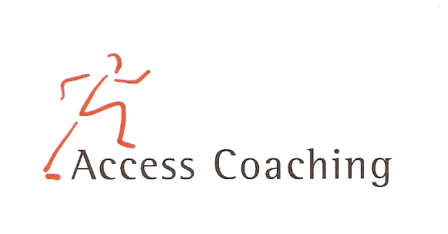

YEAR 1/2 AFTER SCHOOL DODGE BALL CLUB

LANGLEY FIRST SCHOOL

COURSE DATES: Friday 26th Apr, 3rd, 10th, 17th 24th May (3.30 – 4.30pm)

Course Content: The five week course is aimed at increasing the amount of children getting active in competitive fun games and participating in extracurricular activities. All the activities focus on Dodge ball and the development of skills required to participate competently and effectively. Skills developed in the Dodge ball sessions include co-ordination, balance, agility, throwing and catching.

Personal Requirements: Children are expected to provide their own kit. This should include shorts, t-shirt, trainers / sand shoes and a jumper (for possible outdoor sessions). Children are required to bring a still drink.

Applications: All applications should be made by completion of the attached form. Applications should be returned by Friday 5th Apr 2019 to the school office. You will be notified if your child does not get a place.

Course fee: £12.50 for 5 weeks

Access Coaching: For more information please contact James Carron (Director of Coach Development) on 07508217681

YEAR 1/2 AFTER SCHOOL DODGE BALL COACHING
Child’s name:

Address:

Postcode: Tel:

Email: Applicant D.O.B: Age:

Langley First School Class:___________

Please inform us of any Medical Information or Special Requirements:
____________________________________________________________________________

Emergency Contact number:______________________

I would like my child to participate in the after school Dodge ball coaching course and I enclose the course fee of £12.50 (cash or cheque made payable to Access Coaching).

I understand that Access Coaching cannot be held liable for any personal loss or injury that the participant may sustain whilst attending one of the coaching courses. I understand my child has enrolled for 5 weeks of Dodge ball coaching and any failure to attend cannot be refunded.

Signed:..……………………………………………………………………… (Parent/Guardian)

