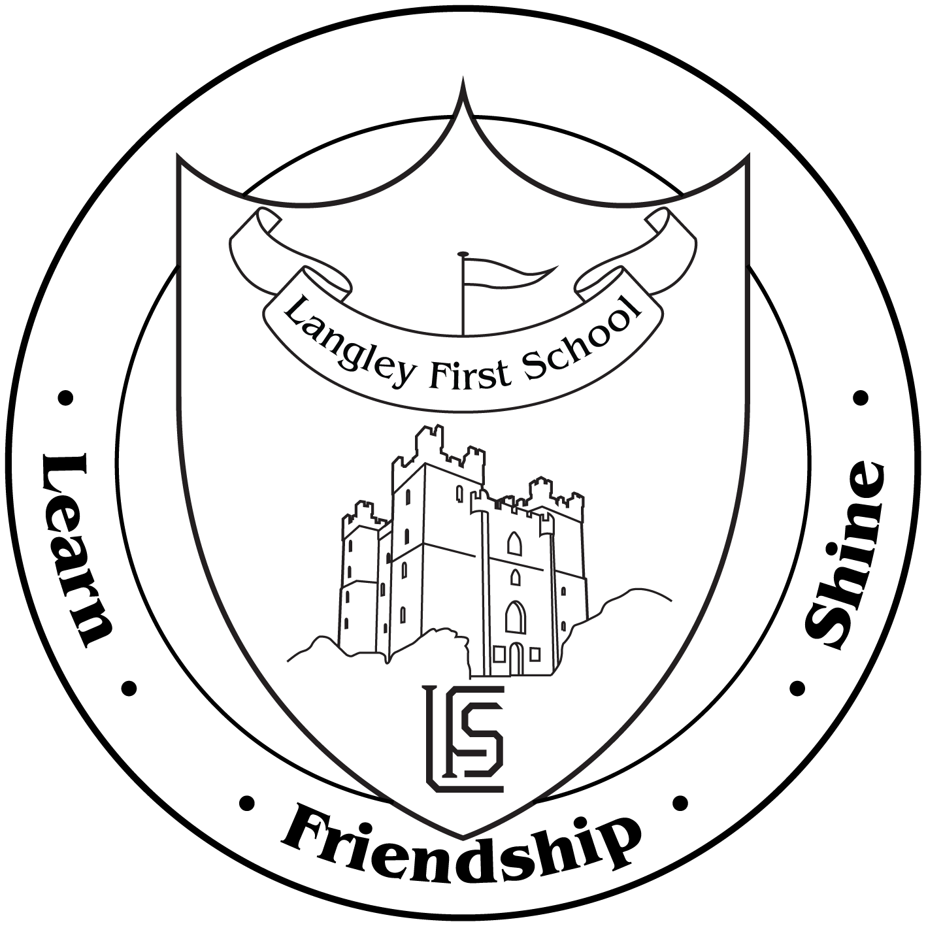

Langley First School

Dear Parent,

As part of our current topic Victorians we have arranged an exciting visit to Beamish Museum, on Tuesday 11th June.

Children are encouraged to come in fancy dress e.g. flat cap/mop hat/waistcoat/aprons. (School may be able to help with some items). They will also require a suitable coat and appropriate shoes in case of wet weather.

The organised workshop will enable the children to experience Victorian School Life.

Under the 1988 Education Act we are unable to charge for such outings. However, we are asking if parents could contribute £16.00 towards the cost. The cost will include transport, insurance, admission into the museum and a 1 hour workshop at the school. It must be stressed that this would be an entirely voluntary contribution.

Travel will be by coach to and from the Museum. The bus will leave school at 9.15 a.m. and will be back by 3.30 p.m.

As this is a full day trip children will require a packed lunch, (no glass bottles please). This will need to be in a backpack which your child will need to carry all day.

We are confident that the children will thoroughly enjoy the visit and it will enhance many parts of the National Curriculum.

If you are able to help please indicate on the slip below.

Yours sincerely,

Mr Mitchinson / Mrs Marron/Mrs Wood
Please complete and return no later than Monday 18th June.

I give permission for:- Child’s Name______________________________ Class______to go to Beamish Museum on Tuesday 11th June.

I am able / unable to help with the visit.

I wish to make a voluntary contribution of £______

Signed_________________________________ Date________________

