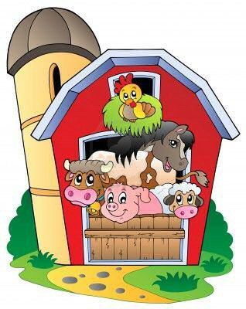
Langley First School Nursery

Whitehouse Farm Trip

Dear Parents,

Morning Nursery

We have arranged for the Nursery children to go on a trip to Whitehouse Farm on Thursday 11th July. We will leave nursery at 9.20 a.m. and arrive back at school by 3.15 p.m. Please arrive at nursery at 8.45a.m.

Afternoon Nursery children will be going on Wednesday 10th July and therefore there will be
no morning Nursery session that day.

Under the 1988 Education Act we are unable to charge for such outings, however we are asking if parents would contribute £16.50 towards the cost. It must be stressed that this is an entirely voluntary contribution and, with the parents permission all children will be going on the trip.

The cost of the trip includes bus travel, insurance and entrance fee to the farm.

All children must have a packed lunch, (no glass bottles or cans – no nuts or nut products or eggs please) and suitable clothing. It would be appreciated if the children could bring with them a backpack which they would carry themselves. Please make sure that your child has sun cream on prior to the trip.

We will need parent helpers but numbers will be limited due to spaces on the bus. If you can help on the trip please indicate on the slip below. No younger children will be allowed on the trip for safety reasons.

Please send the reply into school no later than Friday 17th May, so we can finalise numbers and inform parents if they will be needed.

Many thanks

Mrs M C Routledge and Mrs K Ramsay

Please complete and return in an envelope: Morning Nursery

Child’s name______________________________

I give permission for my child to go to Whitehouse Farm on Thursday 11th July

I enclose a voluntary contribution of £_______

I acknowledge that there will be no Nursery session on Wednesday 10th July

I would like to be a parent helper on the trip to Whitehouse Farm.

Signed_________________________________ Date__________________

