

Dear Parent/carer

**Family Clubbercise – Tuesday 25th June, 2019**

After a successful rave in March, we are happy to announce that Clubbercise is back!

We would like to offer you and your child the opportunity to take part in a Family Clubbercise event! This is a great opportunity for you and your child to participate in some fun and engaging physical activity together.

Family Clubbercise is a fitness, fun rave aimed at pupils from year 1 to year 4, to attend with their family. Simple to follow dance based routines, performed in a darkened room with disco lights and UV. Each ‘clubber’ will be provided a pair of glow sticks to wave and encourage to wear as much neon as possible. Get fit, be happy, sing, dance and whoop along to the biggest club anthems from the 1990s to the present day.

The event will take part on Tuesday 25th June 5-6pm. Tickets are £2.00 per child and £3.00 per adult.

Please complete and return the reply slip below as soon as possible.

Yours sincerely,

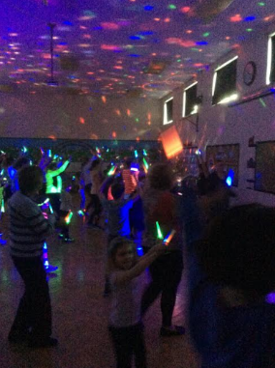Miss F Easton

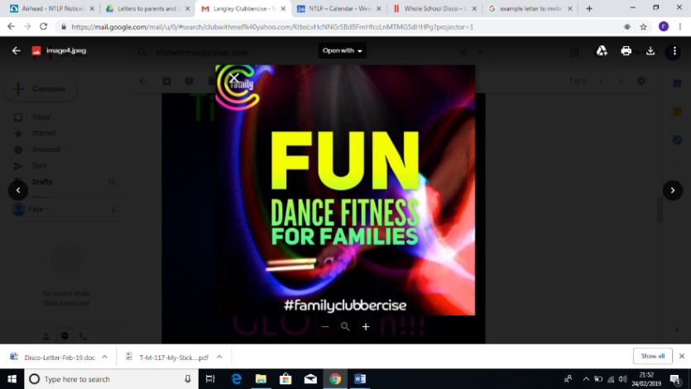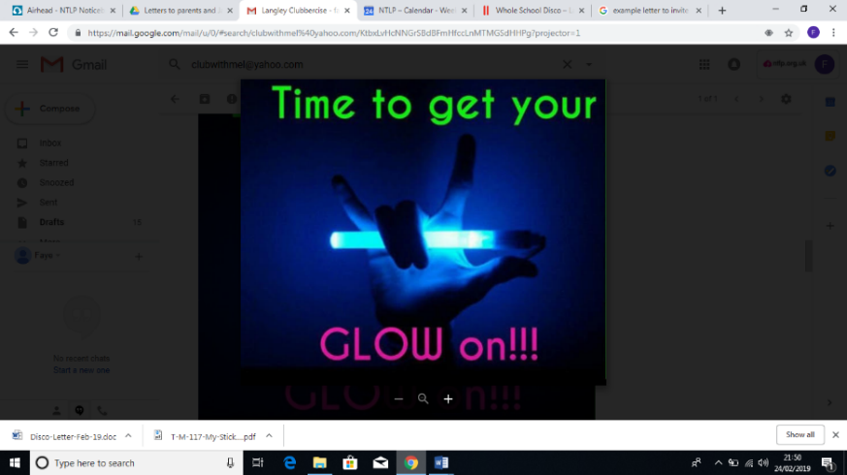

**Family Clubbercise**

**Tuesday 25th June, 2019**

**Child name: Class:**

Adult ticket(s)

Child ticket(s)