Hello Year 1 and Year 2,
Do you like playing with computers or making things work by giving them instructions? If you do then why not come along to the Learn IT Compute IT Computing Club? Examples of the type of things you will be doing at the club include (but not limited to):
Learning to code using fun robots like botley the coding robot. Botley engages children in a basic form of coding utilising step coding and logic, encouraging early programming skills will develop critical thinking and problem solving in young learners.
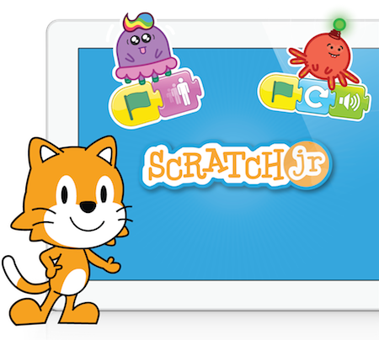
Children can easily program Botley to perform a variety of actions including movement, sound and avoiding objects.

Creating graphical programs with Scratch Jr, a younger version of the well respected and widely used Scratch programming language. Introducing children to writing programs and games using blocks of code and developing skills for more complex programs as they make their way through school
My experience with computing and coding includes over 14 years of teaching, developing resources for use by others, running STEM activities and other community coding activities. In addition to teaching I have had extensive experience working professionally in the IT sector. I am also a Raspberry Pi Certified Educator.
The club will run for 5 weeks on Tuesdays after school from 3.30 to 4.30 commencing on Tuesday 11th June until Tuesday 9th July. The cost for the club is £32.50. There is a limit of 16 spaces at the club
Please respond by completing and returning the attached reply slip by Friday 7th June.
Best wishes
Marty from Learn IT Compute IT

I would like my son/daughter to attend the Learn IT Compute IT Computing Club

Pupils name_________________________________________ Class_______________

I am including payment for £32.50 for the Computing Club

Signature of parent/guardian _____________________________________________________

