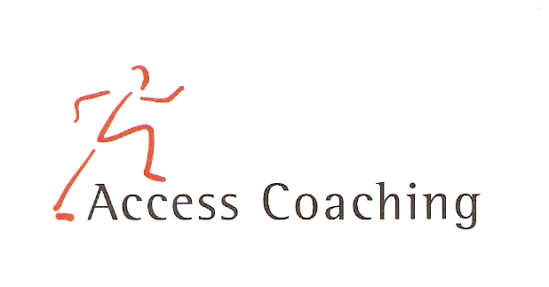

KEY STAGE 2 AFTER SCHOOL TAG RUGBY

LANGLEY FIRST SCHOOL

COURSE DATES Mon 9th, 16th, 23rd, 30th Sept & 7th, 14th, 21st Oct(3.30 – 4.30pm)

Course Content: The seven week course is aimed at increasing the amount of children getting active in non competitive fun games and participating in after curricular activities. All the activities focus on Tag Rugby and developing the skills required to participate competently and effectively. Skills developed in the Tag Rugby sessions include passing, Tagging, scoring tries and small sided games, including the elements of team tactics.

Personal Requirements: Children are expected to provide their own kit. This should include shorts, t-shirt, trainers / sand shoes and a jumper (for possible outdoor sessions). Children are required to bring a still drink.

Applications: All applications should be made by completion of the attached form. Applications should be returned by Monday 9th Sept 2019 to the school office. Everyone will get a place unless otherwise notified.

Course fee: £17.5 per 7-week course

Access Coaching: For more information please contact James Carron (Director of Sport and Coaching) on 07508217681

KEY STAGE 2 AFTER SCHOOL TAG RUGBY
Child’s name:

Address:
Postcode:

Tel: Email: Applicant D.O.B: Age:

Langley First School Class:___________

Please inform us of any Medical Information or Special Requirements:
____________________________________________________________________________

Emergency Contact number:______________________

I would like my child to participate in the after school Tag Rugby coaching course and I enclose the course fee of £17.5 (cash or cheque made payable to Access Coaching).

I understand that Access Coaching cannot be held liable for any personal loss or injury that the participant may sustain whilst attending one of the coaching courses. I understand my child has enrolled for 7 weeks of Tag Rugby coaching and any failure to attend cannot be refunded.

Signed:..……………………………………………………………………… (Parent/Guardian)

