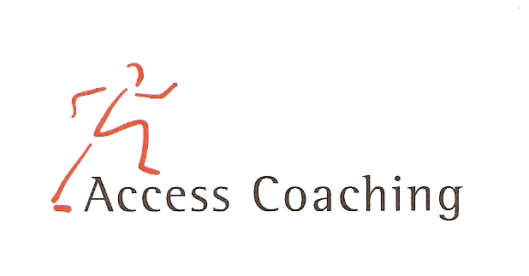

YEAR 1 & 2 AFTER SCHOOL MULTI SKILLS

LANGLEY FIRST SCHOOL

COURSE DATES: Wed 11th, 18th, 25th Sept & 2nd, 9th, 16th, 23rd Oct
(3.30 – 4.30pm)

Course Content: The seven week courses are aimed at increasing the amount of children getting active in non competitive fun games and participating in after curricular activities. All the activities focus on fun and the development of skills required to participate competently and effectively. Skills developed in the sessions include co-ordination, dynamic and static balance, agility and speed through participation in fun activities.

Personal Requirements: Children are expected to provide their own kit. This should include shorts, t-shirt, trainers / sand shoes and a jumper (for possible outdoor sessions). Children are required to bring a still drink.

Applications: All applications should be made by completion of the attached form. Applications should be returned by Wednesday 11th Sept 2019 to the school office. Everyone will get a place unless otherwise notified

Course fee: £17.5 per 7-week course

Access Coaching: For more information please contact James Carron (Director of Sport and Coaching) on 07508217681

YEAR 1 & 2 AFTER SCHOOL MULTI SKILLS
Child’s name:

Address:
Postcode:

Tel: Email: Applicant D.O.B: Age:

Langley First School Class:___________

Please inform us of any Medical Information or Special Requirements:
____________________________________________________________________________
Emergency Contact number:______________________

I would like my child to participate in the after school Multi Skills coaching course and I enclose the course fee of £17.5 (cash or cheque made payable to Access Coaching).

I understand that Access Coaching cannot be held liable for any personal loss or injury that the participant may sustain whilst attending one of the coaching courses. I understand my child has enrolled for 7 weeks of Multi Skills coaching and any failure to attend cannot be refunded.
Signed:..……………………………………………………………………… (Parent/Guardian)

