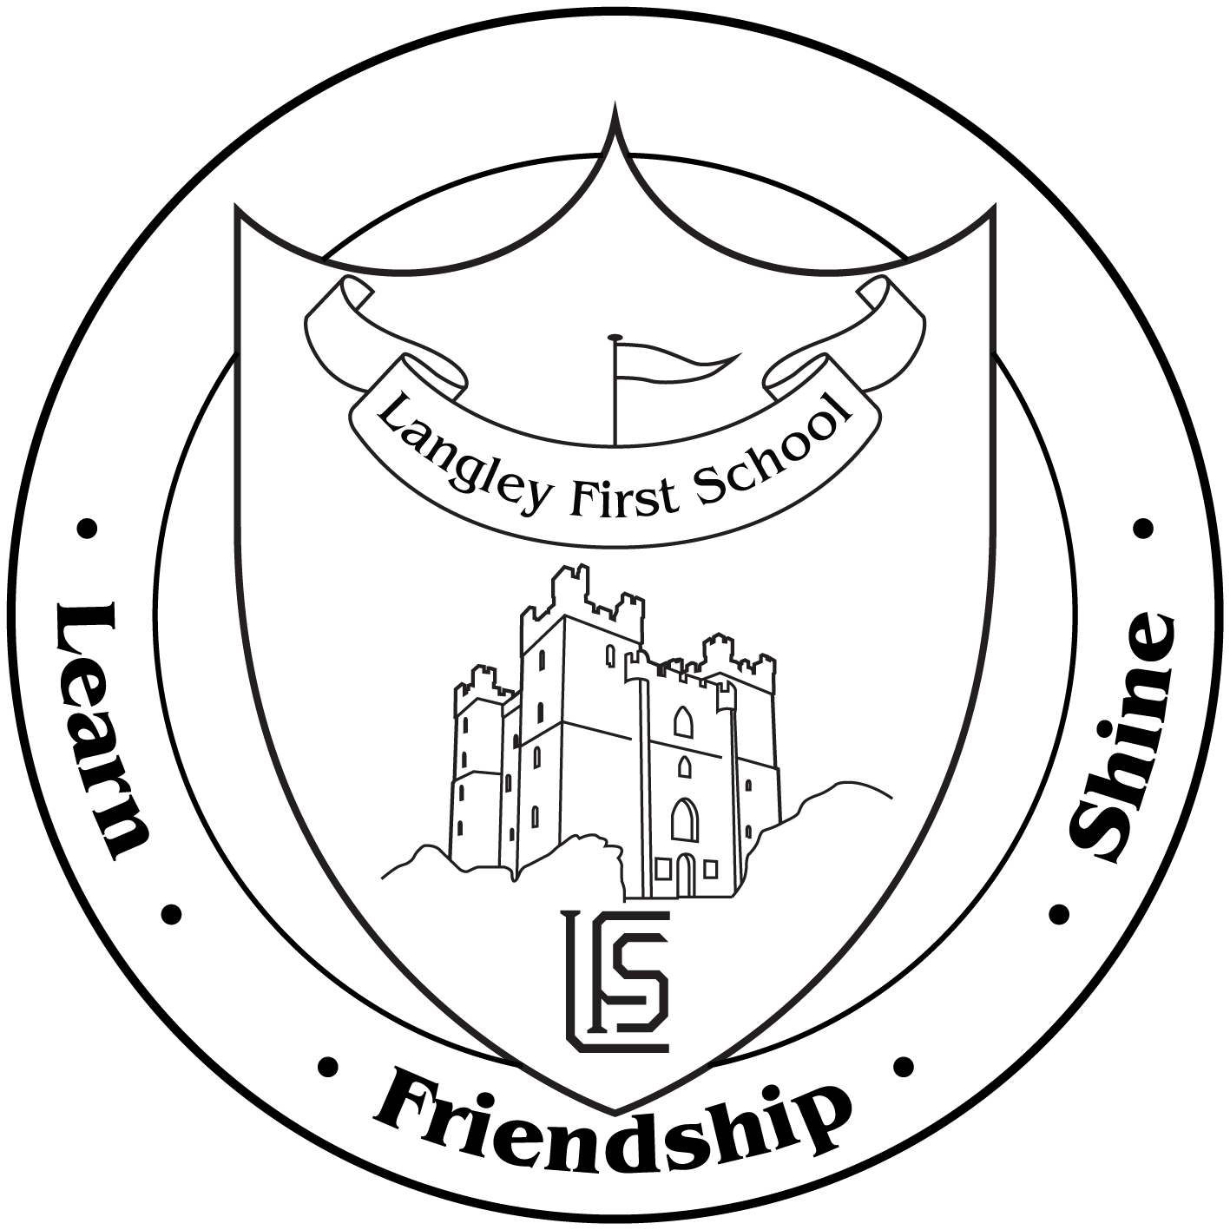

Dear Parents and Carers,

This term we’re collecting Team GB stickers with Aldi’s Kit for Schools for the chance to win £20,000 for our school!

From the 6th September to the 3rd November, when you spend £30 or more in any Aldi store, you’ll receive a special Team GB sticker. If our school works together to collect **300 stickers**, we will automatically receive an exclusive school sports kit, in addition to being added into a prize draw for £20,000!

**Please send any stickers you receive into school with your children and we will add them to our sticker poster.**

The Aldi’s Kit for Schools campaign supports the aims of Get Set to Eat Fresh, Aldi and Team GB’s award-winning schools’ programme, which has already beaten its target to reach 1.2 million young people in the UK by 2020, reaching over 1.5 million young people since it was created.

Thank you so much for your support- we look forward to receiving any stickers you collect! Remember, stickers are available until 3rd November!

Many thanks

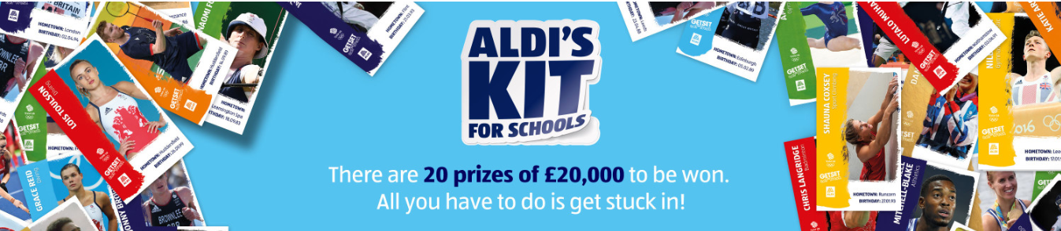Miss F Easton  
PE Lead