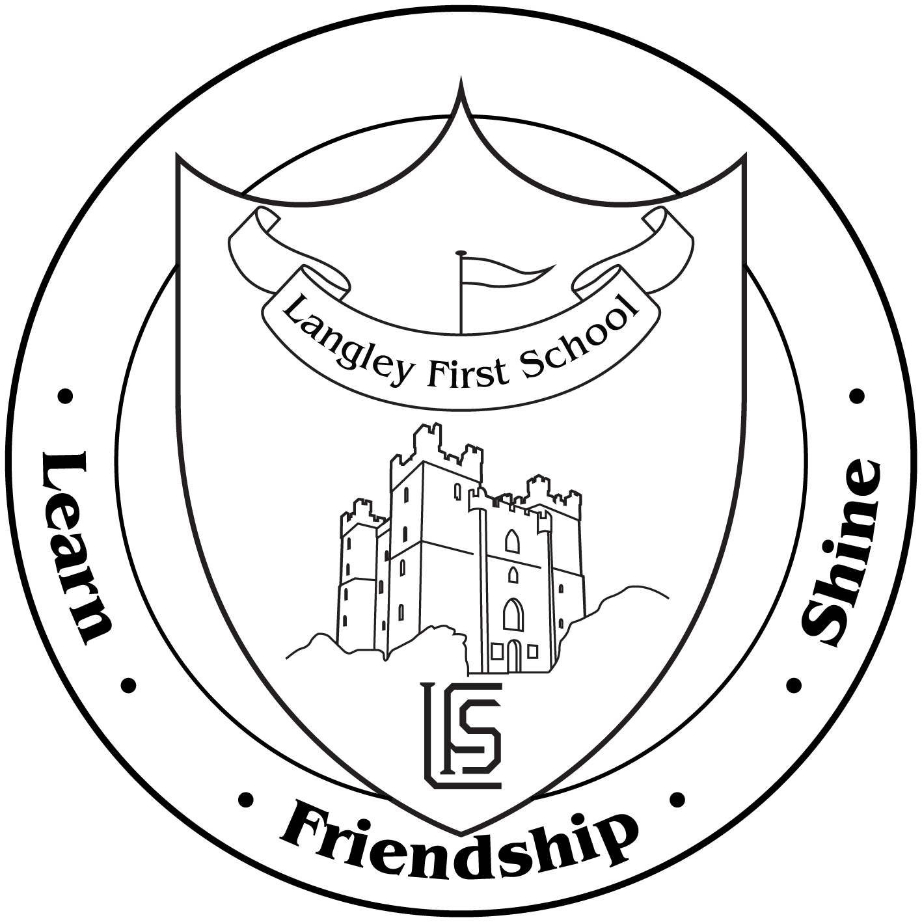

Year 2 – Discovery Museum Trip

Dear Parents and Carers,

On Wednesday 9th of October, we will be spending the day at The Discovery Museum, where we will learn more about The Great Fire of London as well as look at some of the other exhibits. We will be taking a coach from school at 9.15 and will return by normal pick-up time. Under the 1988 Education Act we are unable to charge for such outings. However, we are asking if parents could contribute £9 towards the cost. It must be stressed that this would be an entirely voluntary contribution.

All pupils will require a packed lunch in a plastic bag with drinks, but NO glass bottles or cans please. Please ensure all items are named clearly. Indicate below if you would like the school to provide a lunch.

Please sign and return the slip below by Monday 23rd September. We will endeavour to let volunteers know if we need their support by Friday the 27th September.

Yours sincerely

Mr Massey and Mrs Pendleton

I give permission for my child ___________ to visit the Discovery Museum.

Enclosed is a voluntary contribution of: £________________

I will/will not be able to help on the school trip.

I would like the school to provide a packed lunch (see attached form)

Signed: ________________________________________ Date: