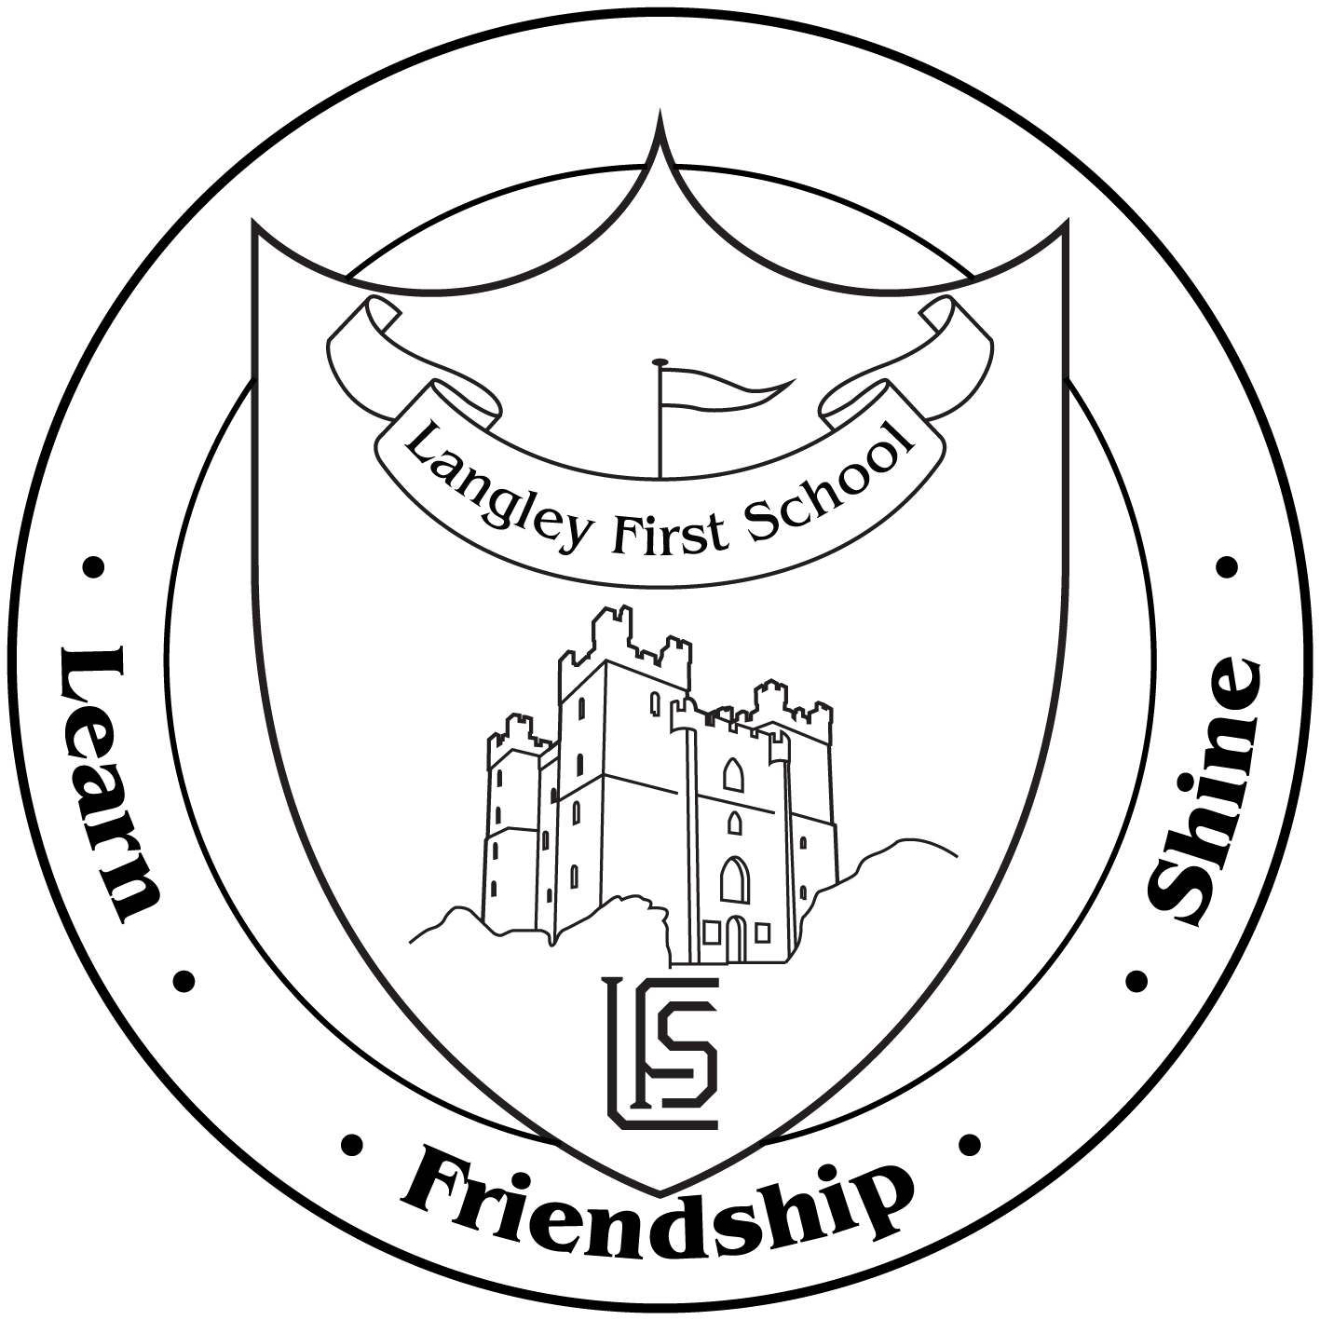

Dear Parents and Carers,

In order to keep you up to date with the latest PE news and information, we have created a new sporting twitter account.

To celebrate this new account, we are running a competition for a chance of winning a family pass to Clip and Climb!

All you have to do is follow us on twitter and tweet a picture of you and the family participating in sporting activities with the hashtag #healthyactivelifestyles. The competition ends on 4.10.19.

@pe_langley

Many thanks

Miss F Easton  
PE Lead