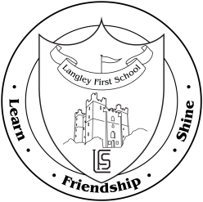**Children’s Showcase Sessions**

**Autumn Term 2019**

Dear Parent / Carer,

During the Autumn and Spring term we offer you the chance to come into school with your child to have a look around the classroom, look in your child’s books and let them show you what they have been doing so far. During the session staff will be present in the classrooms to be available for parents to speak to/share children's work with or discuss the curriculum in general terms.

Having listened to feedback from parents we have slightly changed the arrangements this year in that parents are invited to come in on **any** of the 3 nights listed below.

Once class teachers have passed over the children at the end of the day they will invite parents to come back through the doors and along to their child’s respective classrooms.

The dates for the sessions are;

**Monday 7th October**, **Tuesday 8th October** & **Wednesday 9th October**

Each session will be from 3:30pm – 4:45pm.

Please note that due to prior commitments Class 9 will be available on Monday 7th and Wednesday 9th only and Nursery parents will receive separate invites later in the term.

We hope this will be an excellent opportunity for parents to get an insight into all the fun and creative learning that takes place in school.

Mr. T Jones

Headteacher