**Hello Year 3,**

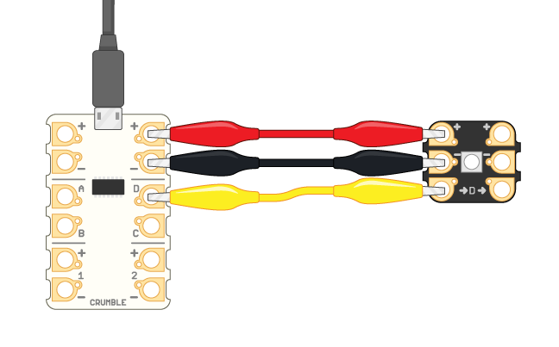Do you like technology? Do you want to know more about how electronics work and writing code for them? If you do then join me this term for an after-school Learn IT Compute IT Computing Club and learn to program.

At the Computing Club, your child will be **writing code to control physical devices including lights, switches and other electronic devices.** They will use a Scratch style programming tool to give instructions to real world devices. It allows your child to **learn real programming skills** in a friendly visual environment. This has the added bonus of developing creative thinking and problem solving skills as well as developing resilience. In the world of programming you are expected to make mistakes and learn from them.

My experience with computing and coding includes over 10 years of teaching, developing resources for use by others, running STEM activities and other community coding activities. In addition to teaching I have had extensive experience working professionally in the IT sector. I am also a Raspberry Pi Certified Educator.

The Computing Club is open to children in Year 3 with a maximum of 16 places available. The participants will work individually and in pairs with the aim of developing collaborative skills to produce more complex creations. The club will run on **Wednesdays after school from 3.30 to 4.30 for 5 weeks commencing on Wednesday 18thth September and finishing on Wednesday 23rd October**. **The cost to attend the club is £30.**

**NOTE there is no session on Wednesday 9th October**

**Please respond by completing and returning the attached reply slip by Friday 13th September.**

Best wishes

Marty from Learn IT Compute IT

I would like my son/daughter to attend the Learn IT Compute IT Computing Club

Pupils name_________________________________________ Class_______________

I am including payment for £30 for the Computing Club

Signature of parent/guardian _____________________________________________________