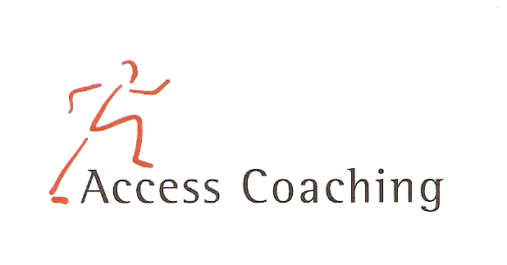

YEAR 3/4 AFTER SCHOOL DODGE BALL CLUB

LANGLEY FIRST SCHOOL

COURSE DATES: Mon 4th, 11th, 18th, 25th Nov & 2nd, 9th Dec (3.30 – 4.30pm)

Course Content: The six week course is aimed at increasing the amount of children getting active in competitive fun games and participating in extra-curricular activities. All the activities focus on Dodge ball and the development of skills required to participate competently and effectively. Skills developed in the Dodge ball sessions include co-ordination, balance, agility, throwing and catching.

Personal Requirements: Children are expected to provide their own kit. This should include shorts, t-shirt, trainers / sand shoes and a jumper (for possible outdoor sessions). Children are required to bring a still drink.

Applications: All applications should be made by completion of the attached form. Applications should be returned by Monday 4th November 2019 to the school office

Course fee: £15 for 6 weeks

Access Coaching: For more information please contact James Carron (Director of Coach Development) on 07508217681

YEAR 3/4 AFTER SCHOOL DODGE BALL COACHING
Child’s name:

Address:

Postcode: Tel:

Email: Applicant D.O.B: Age:

Langley First School Class:___________

Please inform us of any Medical Information or Special Requirements:
____________________________________________________________________________

Emergency Contact number:______________________

I would like my child to participate in the after school Dodge ball coaching course and I enclose the course fee of £15 (cash or cheque made payable to Access Coaching).

I understand that Access Coaching cannot be held liable for any personal loss or injury that the participant may sustain whilst attending one of the coaching courses. I understand my child has enrolled for 6 weeks of Dodge ball coaching and any failure to attend cannot be refunded.

Signed:..……………………………………………………………………… (Parent/Guardian)

