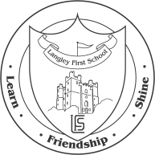

Langley First School

Dear Parent,

As part of Year Two’s curriculum studies of Judaism, we have arranged a visit to Gosforth Synagogue on Thursday 24th October.

This is a half day visit and the children will travel by coach, leaving school at 9.20 a.m. and return at 11.30 a.m.

Under the 1988 Education Act we are unable to charge for such outings. However, we are asking if parents could contribute £3.50 towards the cost.

We will need parent helpers, so if you are able to help please indicate on the slip below and return by Friday 18th October.

Yours sincerely,

Mr Massey and Mrs Pendleton
.................................................................................................................................................................
Please complete and return:
□ I give permission for my child__________________________Class_______
to travel by coach to Gosforth Synagogue on Thursday 24th October.
□ I am able / unable to help with supervision on Thursday 24th October.
We will confirm parent helpers by Monday 21st October.
□ I wish to make a voluntary contribution of £_____

Signed:________________________________________ Date: ___/___/___

