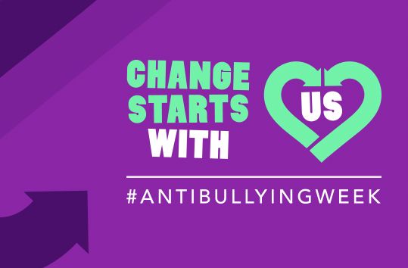


Tuesday 5th November 2019

Dear Parents/Guardians,

‘National Anti-Bullying Week’ 11th-15th November 2019

As you may be aware, next week is national Anti-Bullying Week. At Langley First School we refer to anti-bullying as ‘Safe To Be Me’. The national slogan this year is ‘Change starts with us’. This year’s campaign aims to help children celebrate what makes them, and others, unique. At Langley First School our aim is to ensure that all pupils and parents are aware of issues of bullying and how our school addresses these in our curriculum. During this time we will review our schools’ ‘Safe To Be Me’ Charter and looking at what this means to the children in our school. We will also look at the definition of bullying, which we always use to address any bullying concerns that may arise. This is our definition;

- Bullying is on purpose
- Bullying is hurtful
- Bullying is over and over again

In our assembly we will look at the different types of bullying and our ‘Safe To Be Me’ Charter. The children will then have opportunities in class to learn more about a particular aspect of bullying. The children will work with their houses to create a whole school display - look out for the finished piece on our school website and Twitter!

On Friday 15th November, the children are invited to come to school wearing anything they choose, from bad taste to their favourite dress up costume to their school inform. We want to express to the children how it doesn’t matter what we look like, it’s how we act and behave which is important. As this also coincides with Children in Need we would like to ask for a £1 donation towards the appeal this year.

Next week we will be sending home an example of our Safe To Be Me Charter with some more information for you to use as a good starting point for conversations at home. To also help with your discussions at home you may wish to visit the following link
https://www.anti-bullyingalliance.org.uk/tools-information/advice-parents/interactive-anti-bullying-tool-parents

We would like to thank you for your support, once again, during this very important week.

Thank you for your support,

Mrs Ramsay
PSHE Lead

