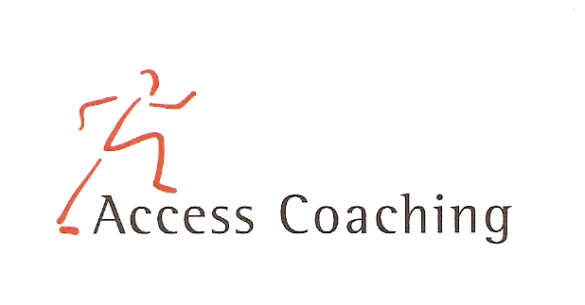

RECEPTION AFTER SCHOOL BALL SPORTS

LANGLEY FIRST SCHOOL

COURSE DATES Wed 8th, 15th, 24th, 29th Jan & 5th, 12th Feb (3.30 – 4.30pm)

Course Content: The six week course is aimed at increasing the amount of children getting active in non competitive fun games and participating in after curricular activities. All the activities focus on Handball, Bench ball, Balance ball, Dodge ball, Football and the development of skills required to participate competently and effectively. Skills developed on the ball sports sessions include throwing, dribbling, passing, blocking, and shooting, and the elements of the team tactics.

Personal Requirements: Children are expected to provide their own kit. This should include shorts, t-shirt, trainers / sand shoes and a jumper (for possible outdoor sessions). Children are required to bring a still drink.

Applications: All applications should be made by completion of the attached form. Applications should be returned by Thurs 19th Dec 2019 to the school office.

Course fee: £15 per 6-week course

Access Coaching: For more information please contact James Carron (Director of Sport and Coaching) on 07508217681

RECEPTION AFTER SCHOOL BALL SPORTS COACHING
Child’s name:

Address:
Postcode:

Tel: Email: Applicant D.O.B: Age:

Langley First School Class:___________

Please inform us of any Medical Information or Special Requirements:
____________________________________________________________________________

Emergency Contact number:______________________

I would like my child to participate in the after school ball sports coaching course and I enclose the course fee of £15 (cash or cheque made payable to Access Coaching).

I understand that Access Coaching cannot be held liable for any personal loss or injury that the participant may sustain whilst attending one of the coaching courses. I understand my child has enrolled for 6 weeks of ball sports coaching and any failure to attend cannot be refunded.
Signed:..……………………………………………………………………… (Parent/Guardian)

