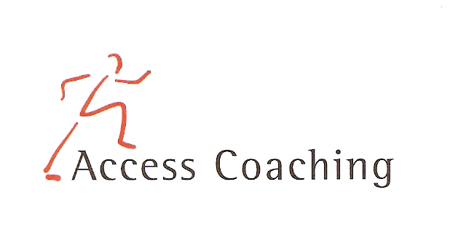

YEAR 3 & 4 AFTER SCHOOL ARCHERY CLUB

LANGLEY FIRT SCHOOL

COURSE DATES: Mon 24th Feb, 2nd, 9th, 16th, 23rd & 30th Mar (3.30–4.30pm)

Course Content: The children will learn the skills to fire the plastic arrow from the plastic bows, using the official GB Archery Arrows Kit. They will develop their skills playing small side games, competitions and a small tournament in the last week. The children will learn the correct terminology for the equipment and the correct way to shot the arrows at the wooden targets, hula hoops and bean bags.

Personal Requirements: Children are expected to provide their own kit. This should include shorts, t-shirt, trainers / sand shoes and a jumper (for possible outdoor sessions). Children are required to bring a still drink.

Applications: All applications should be made by completion of the attached form. Applications should be returned by Mon 24th Feb 2020 to the School office.

Course fee: £15 for 6 weeks

Access Coaching: For more information please contact James Carron (Director of Coach Development) on 07508217681

YEAR 3 & 4 AFTER SCHOOL ARCHERY COACHING
Child’s name:

Address:

Postcode: Tel:

Email: Applicant D.O.B: Age:

Langley First School Class:___________

Please inform us of any Medical Information or Special Requirements:
____________________________________________________________________________

Emergency Contact number:______________________

I would like my child to participate in the after school Archery coaching course and I enclose the course fee of £15 (cash or cheque made payable to Access Coaching).

I understand that Access Coaching cannot be held liable for any personal loss or injury that the participant may sustain whilst attending one of the coaching courses. I understand my child has enrolled for 6 weeks of Archery coaching and any failure to attend cannot be refunded.

Signed:..……………………………………………………………………… (Parent/Guardian)

