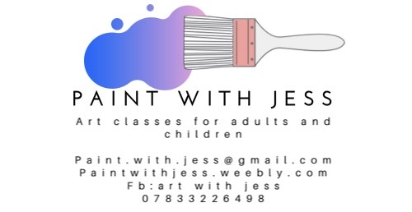

Dear Parent/Carer,

I am delighted to offer year 3 and 4 pupils an after school Art Class where they will have the opportunity to be creative and explore a variety of themes, engage with artists work, and develop skills in different media with a qualified and experienced specialist art teacher.

Art Class will last for 1 hour every Monday after school from 15:30 – 16:30.

For classes running from 24th February until 30th March (6 weeks) cost will be £36. All materials and resources are included in the cost. Each week your child will have the chance to design and create a piece of artwork in 2D or 3D. We will be using paint, pastels, clay and crayons. There will be something exciting and different each week!

Please ensure that you book your place early as spaces are limited. School will confirm places or otherwise before the end of term (Friday 14th February).

Yours sincerely,
Jess Dougherty

________________________________________________________________________

Year 3 and 4 Art Club

I would like my child _________________________________ class ______________ to take part in the after school art club on a Monday evening and have enclosed £36.
Please make cheques payable to Langley First School.

Signed ___________________________________________ parent/carer.

