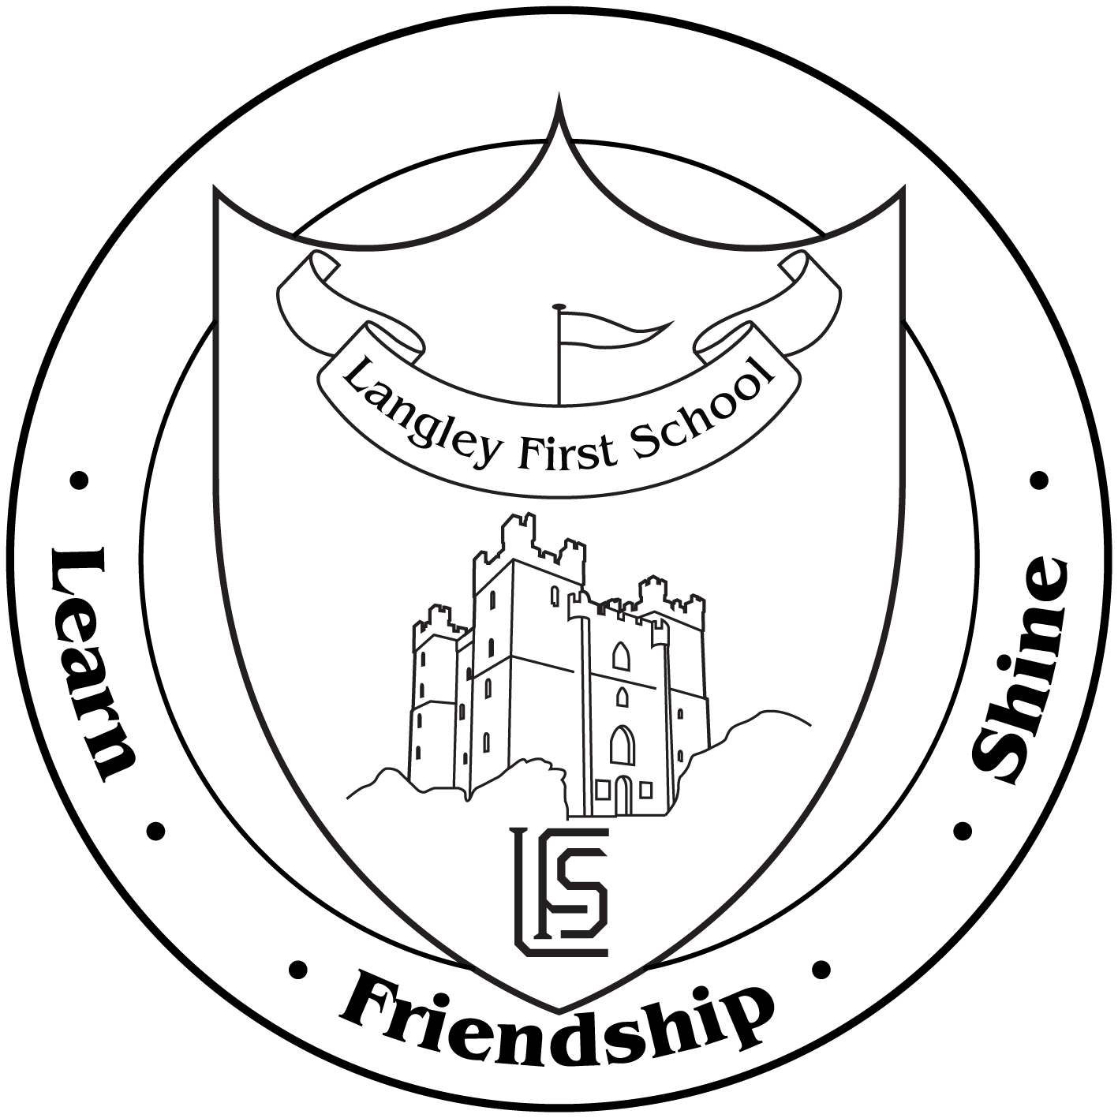

Langley First School

Dear Parents and Carers,

As part of our current topic, dinosaurs, we are arranging a visit to the Great North Museum for Reception children on Wednesday 18th March.

The children will be travelling by coach, leaving school at 9.30 a.m. and returning for 2.30 p.m. approximately. As this is an all day visit the children will need to bring a packed lunch with them. Please be aware that some children have allergies to eggs, nuts and legumes. Also please do not send glass bottles or fizzy drinks in cans. If you wish your child to have a school packed lunch please complete the attached form.

Under the 1988 Education Act we are unable to charge for such an outing. However, we are asking if parents could contribute £6.00 to cover the cost of the visits. It must be stressed that this would be an entirely voluntary contribution and, with their parent’s permission, all Reception children will be going on the visit.

If you are able to help with the visit please indicate below and return the slip no later than Friday 13th March.

Yours sincerely,

Mrs March and Miss Calboutin

Please sign and return the slip below by **Friday 13th March**.

I give permission for my child ___________________________ class____ to visit the Great North Museum on Wednesday 18th March.

Enclosed is a voluntary contribution of: £_____

I will/will not be able to help on the school trip.

Please state full name if you are able to help:

_____________________________________________________

Signed_________________________________Date_______________