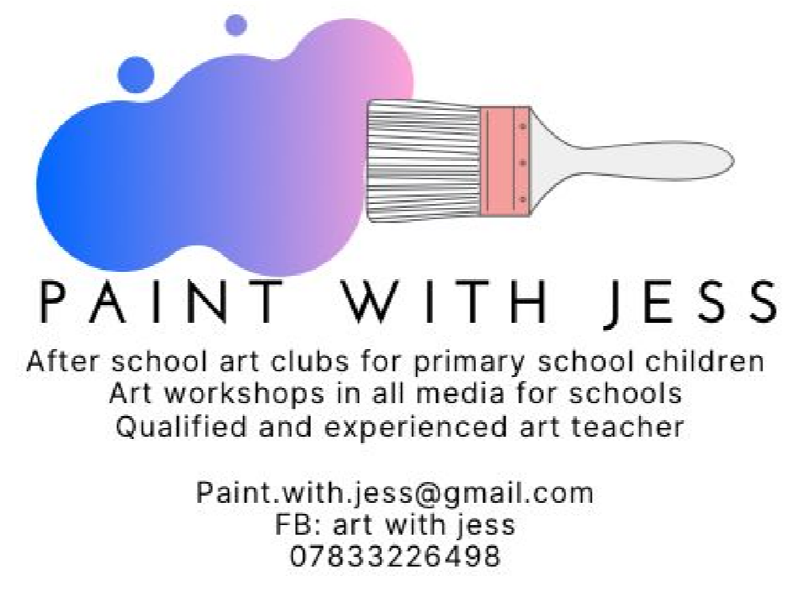

Dear Parent/Carer,

I am delighted to offer year 3 and 4 pupils an after school Art Class where they will have the opportunity to be creative and explore a variety of themes, engage with artists work, and develop skills in different media with a qualified and experienced specialist art teacher.

Art Class will last for 1 hour every Monday after school from 15:30 – 16:30.

For classes running from 2nd November until 14th December (7 weeks) cost will be £42. All materials and resources are included in the cost. Each week your child will have the chance to design and create a piece of artwork in 2D or 3D. We will be using pens, paint on paper and canvas, pastels, and crayons. There will be something exciting and different each week!

Spaces are limited to 25 so please ensure you book your place early to avoid disappointment. You will receive a notification from the school if your child has a place by Friday 19th October.

I look forward to seeing your child there!

Yours sincerely,
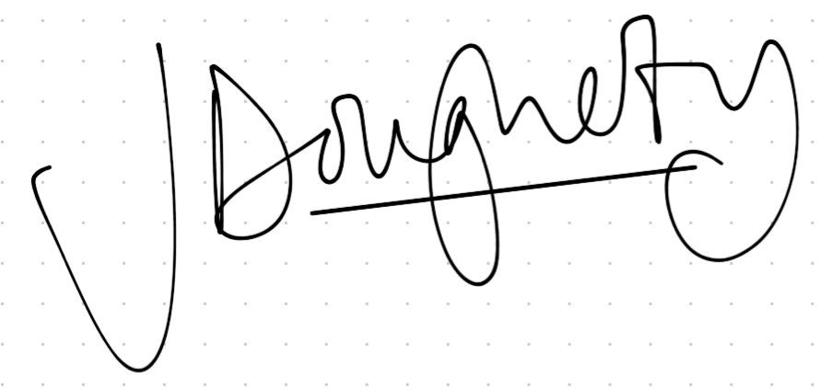
Jess Dougherty

______________________________________________________________________

Year 3 and 4 Art Club

I would like my child _____________________________________ class ____________ to take part in the after school Art Club with Jess on a Monday evening and have enclosed £42 .
Please make cheques payable to Langley First School.

Signed ___________________________________________ parent/carer.

