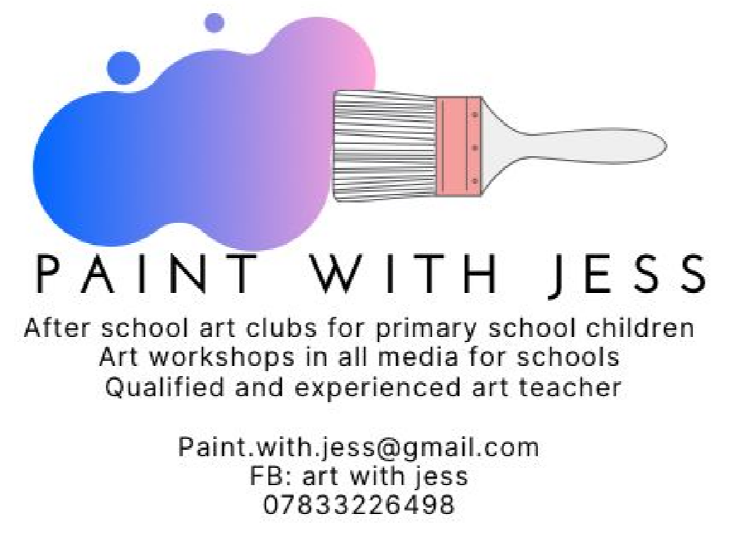

Dear Parent/Carer,

I am delighted to continue to offer year 3 and 4 pupils the after school Art Class where they will have the opportunity to be creative and explore a variety of themes, engage with artists work, and develop skills in different media with a qualified and experienced specialist art teacher.

Art Class will last for 1 hour every Monday after school from 15:30 – 16:30.

For classes running from 11th January until 8th February (5 weeks) cost will be £30. All materials and resources are included in the cost. Each week your child will have the chance to design and create a piece of artwork in either 2D or 3D. We will be using a variety of different materials including pens, acrylic and watercolour paint on paper and canvas, pastels, and crayons. There will be something exciting and different each week! Please pay £30 using the school money online payments when school sends you the link.

Spaces are limited to 25. Places are confirmed by making a payment to the school office on a first come first served basis. Payment must be received no later than Thursday 7th January 2021.

I look forward to seeing your child there!

Yours sincerely,
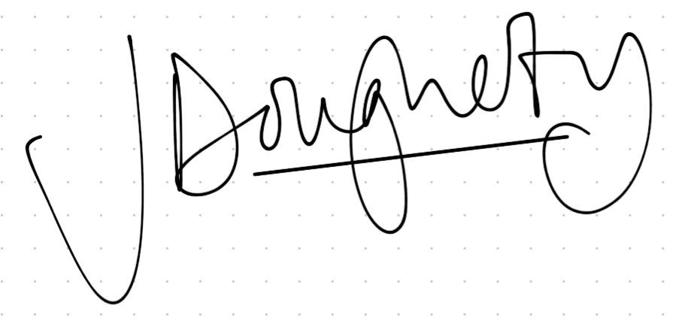
Jess Dougherty

_______________________________________________________________________

Year 3 and 4 Art Club

I would like my child _____________________________________ class ____________ to take part in the after school Art Club with Jess on a Monday after school and will pay £30 online .

Signed ___________________________________________ parent/carer.

