11 February 2021

Dear Parents,

In order to continue to limit transmission of COVID-19 across North Tyneside we are asking parents to let the school know if their child tests positive during the February half term.

If your son or daughter receives a positive COVID-19 test during the half term week, please contact the school immediately on and provide the following information:

Name of child

Class/year group

Date of the COVID-19 test

Does the child have symptoms? Yes or No

What date did the symptoms start?

What date did the child last attend school?

It is very important that you provide this information so that the school can identify any close contacts that your son or daughter may have had in school during their infectious period. The school will then follow up close contacts and request that they isolate for 10 days to prevent further transmission of COVID-19.

Please note that you should also report any close contacts that your child has have outside the school setting through NHS Test and Trace.

Thank you for your help in this matter

Yours sincerely,

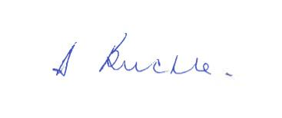
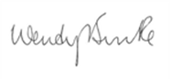

Diane Buckle
Assistant Director of Education
Wendy Burke
Director of Public Health

