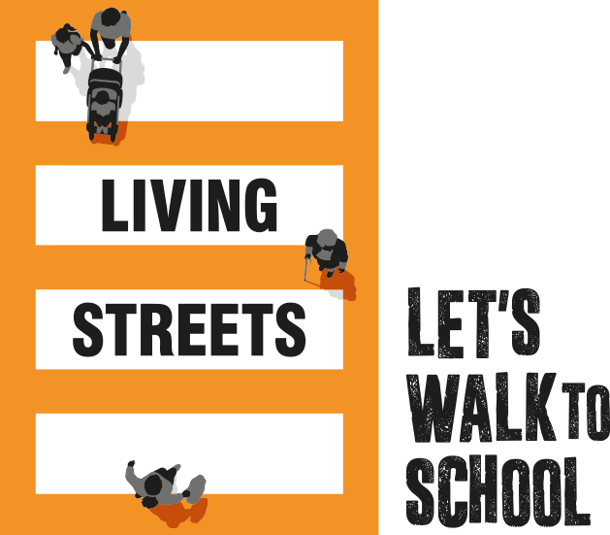
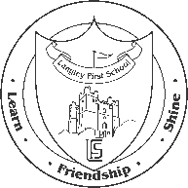

Friday 5th March

Re: WOW challenge

Dear parent/carer,

In conjunction with our School Streets initiative and in line with the children returning to school next week we have chosen to be part of an exciting nationwide challenge to encourage more children and their families to walk to school. WOW – the year-round walk to school challenge is delivered by Living Streets, the UK charity for everyday walking, to help as many children as possible experience the benefits of walking to school.

WOW is a pupil-led initiative where children self-report how they get to school every day. If they travel sustainably (walk, cycle or scoot) twice a week for a month, they get rewarded with a badge. It's that easy!

What are the benefits of walking to school?
Walking to school helps children feel happier and healthier and they arrive refreshed, fit and ready to learn. More families walking means fewer cars on the road during the school run, helping to reduce congestion and pollution at the school gates.

What if you can’t walk to school?
If you live too far away or don’t have time to walk the whole way to school, you can Park and Stride to help your child earn their WOW badge. Park or hop off public transport at least ten minutes away from the school and walk the rest of the way.

Is walking to school safe at this time?
Walking to school remains an effective way to reduce congestion and improve road safety at the school gates, while increasing physical activity and benefitting pupil wellbeing. The government is actively working with schools and local authorities to encourage families to walk to school whenever they can during this time. However, it is important that measures in place to protect everyone’s health are always observed.

Living Streets understands that schools face unique challenges at present, which create uncertainty for staff, pupils and families. We are committed to helping schools adapt to changing circumstances, ensuring that everyone involved in our walk to school initiative stays safe.

Did you know? The WOW badges are made using excess yoghurt-pot material previously destined for landfill and are produced in the UK, minimising our carbon footprint. The packaging we use is 100% biodegradable. Living Streets is proud to have found a brilliant use for landfill material. Thousands of schools and around one million pupils are enjoying the benefits of walking to school across the UK. Will you join us? If you have any questions about the programme, please contact the school office, or for more information visit livingstreets.org.uk/WOW

Let’s swap those school runs for school walks!

Mr T Jones
Headteacher

