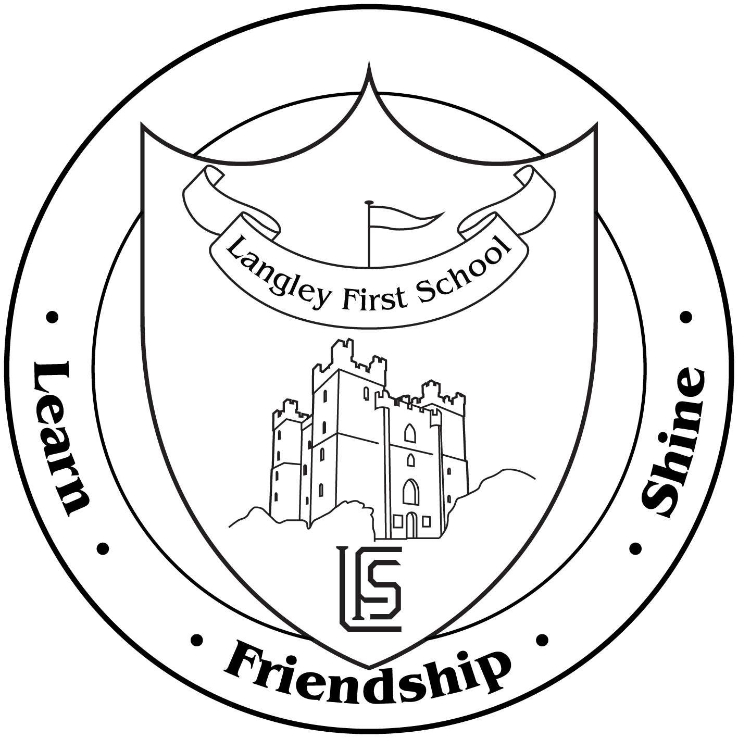Monday 7th June 2021

**RE: Summer term dates**

Dear parent / Carer,

Welcome back to the final term of 2021! I hope that you managed to have some time to enjoy the lovely weather that we have been lucky enough to have experienced over the half term break, and hopefully will stay with us for some time to come.

Please find below some key information for the term ahead and key dates for events that we have planned and hope to be able to go ahead with. As with everything in this current time, we offer these in good faith but will communicate to you through email, text and twitter any changes that may have to be managed.

**Weather**

With hopefully the sun set to be with is for a while, please make sure that your child brings their water bottle to school. This MUST only contain water and not juice or any other drink.

We also ask that you apply suncream to your children prior to them coming to school. Whilst we are not able to re-apply this during the day, we can encourage them to re-apply themselves if you provide them with their own suncream (please make sure it is named). Due to allergies we are not able to let children share another child’s suncream.

**Transition**

This year we will be holding all our transition for year 1 – 4 online for parents. There will be a short video from the class teachers and all the information that you will need prior to your child starting in their new year group will be sent to you and posted online.

For the children, on Tuesday 29th June, they will get the chance to spend the day in their new classroom with their new teacher. We will go through with the children exactly what they will need to do but the times and exit routes for the end of the day **will not change.** Therefore parents will need to collect at the current times.

We hope to be able to offer the chance for parents to access the school in the new term, this will clearly be very dependent on restrictions but further information and plans will be sent out in the Autumn term.

**New Parent Governors**

Well done to Mrs Anderton and Mr Hood for being voted on to our Governing Body. Thank you also to all the candidates who put themselves forward this time. I am sure parents found it a really difficult decision to make with such skilled and experienced parents offering their time and support. This clearly showed in how close the voting was in the end so thank you again.

**Covid arrangements**

As there has been no change to the Government guidance for schools we continue to run with the same protocols in place as before the half term holiday. Whilst there has been lots of speculation in the media concerning the next steps of the Governments road map, only once we have had official guidance will we be able to change current arrangements. As always, once this does happen we will communicate to parents in good time and work to ensure there is little disruption to the children’s education.

It goes without saying that the practice of reporting any tests or symptoms remains as important as ever. Please ensure that school is kept informed of any concerns around symptoms of covid. If in doubt we recommend getting tested and isolating until results are confirmed.

**Key dates for summer 2**

|  |  |
| --- | --- |
| **Date** | **Event** |
| Monday 7th June | Start of term |
|  | All after school clubs start this week (3:30 – 4:30) |
| Wednesday 9th June | Year 4 Valley Gardens transition assembly (9:30) |
| Friday 11th June | Non – uniform day – request for chocolate tombola prizes |
|  | Year 3 to Monkseaton Middle School (1:30 – 2:45) |
| Monday 14th June | Start of sports fortnight – information to follow but please have PE kit for next 2 weeks |
| Wednesday 16th June | New Reception parents transition meeting group 1 & 2(5:00 – 6:00) |
| Thursday 17th June | New Reception parents transition meeting group 3 & 4 (5:00 – 6:00) |
| Monday 21st June | Bikeability for year 4 starts (children given specific days – please see separate communication) |
| Friday 25th June | Letter sent home with information regarding classes for next year |
| Tuesday 29th June | Transition day – Reception to year 4  Year 4 children attend their new middle schools |
| Wednesday 30th June | Year 4 children attend their new middle schools  New Reception children stay and play – group 1 (4:00 – 5:00) |
| Thursday 1st July | Reception vision screening |
| Friday 2nd July | Friends of Langley summer fair events (all day) |
|  | New Reception children stay and play – group 2 (4:00 – 5:00) |
| Wednesday 7th July | New Reception children stay and play – group 3 (4:00 – 5:00) |
| Thursday 8th July | Year 4 to Jam Jar cinema  New Reception children stay and play – group 4 (4:00 – 5:00) |
|  | Year 3 assembly with Monkseaton Middle School |
| Friday 9th July | Year 4 fun day (PE kits to be worn) |
| Wednesday 14th July | Reports sent home |
| Thursday 15th July | Year 4 coffee morning – details to be shared |
| Friday 16th July | Last day of term |
| Please note, school starts again on Thursday 2nd September 2021  All term dates for next year can be found at [langleyfirst.org.uk/term-dates-2020-2021/](https://www.langleyfirst.org.uk/term-dates-2020-2021/) | |