Dear Parent/Carer,

I am delighted to continue to offer year 3 and 4 pupils the after school Art Class where they will have the opportunity to be creative and explore a variety of themes, engage with artists work, and develop skills in different media with a qualified and experienced specialist art teacher.

Art Class will last for 1 hour on Monday after school from 15:30 – 16:30.

For classes running from 10th January until 14th February (6 weeks) cost will be £36. All materials and resources are included in the cost. No Art Class activity will be repeated as I plan a two-year rolling timetable of activities and content. There will be something exciting and different each week!

The class will be run following all the guidelines set in place by the school regarding Covid.

Spaces are limited to 30. Book early to avoid disappointment. Places are confirmed by making a payment to the school office on a first come first served basis. No refunds can be offered once payment has been made because all resources will have been purchased for the exact number of children. However, if your child can no longer attend you may wish to arrange a replacement child yourself. Payment must be received no later than Friday 7th January to enable accurate planning and resourcing. You will get a link to pay if your child has secured a place.

I look forward to seeing your child there!

Yours sincerely,
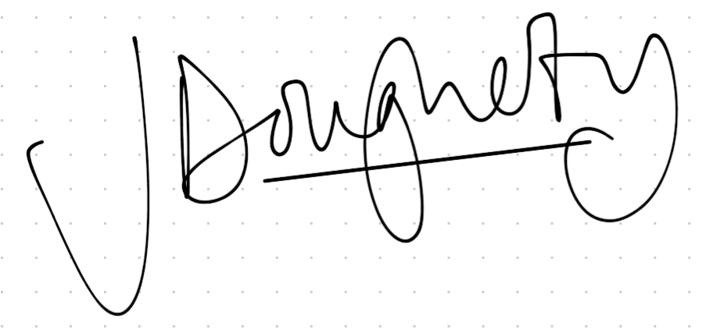
Jess Dougherty

